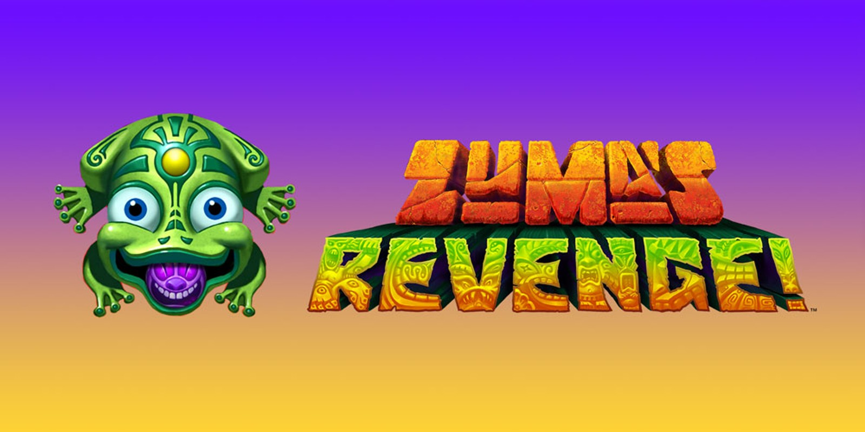

##### **ZUMA’S REVENG!**

##### ***ABOUT:***

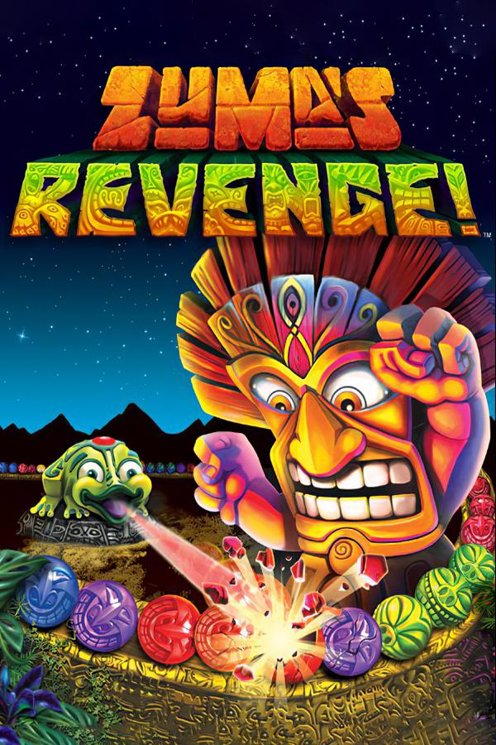

**Zuma revenge is the sequel of the famous online game of the same name, published by Pop cap, which popularized the style and resulted in many variations. This official version of Zuma Revenge online is still effective and will delight all fans of the genre. Note that you can play Zuma's Revenge full screen and you can also get the full version for download.**